# China Daily

# 1.Ten photos from across China:Oct 20–Oct 26

chinadaily.com.cn|Updated:2023-10-27 06:30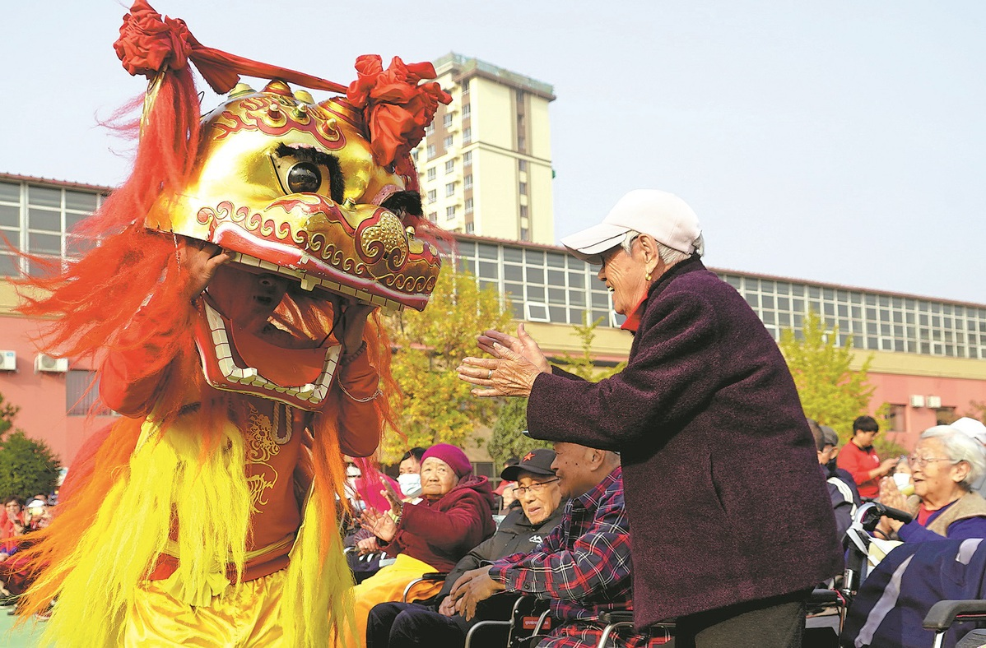

Seniors at a nursing home in Beijing enjoy a traditional lion dance during a cultural event to celebrate the Double Ninth Festival on Oct 23,2023.The festival falls on the ninth day of the ninth month of the Chinese lunar calendar.In Chinese folklore,the number nine is a homonym of the Chinese word jiu,which can mean"a long and healthy life".CHENG GONG/FOR CHINA DAILY

# 2.Festive China:Chongyang Festival

When clear and refreshing autumn arrives and chrysanthemums envelope the world,it's time for the Chinese Chongyang Festival,or Double Ninth Festival.

The Double Ninth Festival falls on the ninth day of the ninth month on the Chinese lunar calendar.In Chinese folklore,the number nine is the largest number-it's a homonym to the Chinese word jiu,which contains the auspicious meaning of"a long and healthy life".

Although people today don’t observe all the traditional customs for the Double Ninth Festival,it’s still the core of the festival to respect the elders.Thanks to social care from their surroundings and love from their families,a growing number of seniors have begun to pay more attention to their later years.

# 3..Eldercare services a fast growing industry

By Li Jia|China Daily|Updated:2024-01-29 06:45

As China charts its course toward high-quality development,developing the"silver economy"has emerged as a pivotal strategy to facilitate that process.Following the emphasis laid on the"silver economy"in key national meetings,the State Council,China's Cabinet,issued the"Opinions on Developing the Silver Economy to Enhance the Well-being of the Elderly"on Jan 15,making it the first dedicated document supporting the development of the"silver economy".

But what exactly is the"silver economy"?And how does it relate to concepts such as market-oriented elderly services,elderly service industry,eldercare industry,aging economy and"silver market"?

Depending on the timing,background,terminology and content of policy documents,the development of the concepts related to the"silver economy"can be divided into four stages.

Year 2000:Socialization and marketization of elderly services.At the end of 1999,the number of people aged 60 or above exceeded 10 percent of China's total population,marking the beginning of an aging population.The focus then was on addressing the pressing issues of inadequate and somewhat mediocre eldercare services.In August 2000,the Central Committee of the Communist Party of China and the State Council issued the"Decision on Strengthening Aging Work",which encouraged social and market entities to participate in the eldercare industry,and promote the socialization and marketization of services for the elderly.

Year 2006:Eldercare services.In 2005,the number of people aged 65 or above exceeded 100 million,with more than 13 million of them aged 80 or above.The State Council's General Office released the"Opinions on Accelerating the Development of Elderly Care Services"in February 2006,which for the first time mentioned the term"elderly care service industry".The document extended the focus beyond elderly care services to include products for elderly people,promoting the development of the market for products for the elderly.

Year 2012:Elderly care industry.As China's working-age population peaked at 940 million in 2012,the population aged 60 or above approached 200 million,constituting a significant percentage of the total population.In July 2012,the Ministry of Civil Affairs issued the"Implementation Opinions on Encouraging and Guiding Private Capital to Enter the Elderly Care Service Industry",mentioning the term"elderly care industry"for the first time and outlining eight main components of the industry.

Year 2020:Silver economy.The term"silver"refers to gray hair,often used as an elegant term for the elderly.In the 1970s,Japan coined the term"silver generation"to avoid the negative connotation of the word"old".At the turn of the century,Western countries,too,introduced terms such as"silver economy","gray-hair economy","longevity economy"and"silver market".In 2018,China witnessed a demographic turning point,with the elderly population surpassing the population aged 0-15.In October 2020,the CPC Central Committee's report made addressing the population aging problem a national policy.And the Outline of the 14th Five-Year Plan for National Economic and Social Development and the Long-Range Objectives Through the Year 2035 marked the inception of the term"silver economy".

The ongoing journey from social services to economic advancement:Analyzing the policy evolution,it's evident that the above concepts,while closely related,are substantially different.The progression from social services to economic development reflects a better understanding of population aging,following a"social services-industry-economy"trajectory.

While socializing and marketizing eldercare services are aimed at addressing the basic needs of the elderly,the focus on the"silver economy"has extended to include diverse services such as healthcare,culture,and law,meeting the multifaceted needs of the elderly.This distinction highlights the difference between the concepts of"elderly"and"aging".

The"elderly care industry"and"anti-aging industry"were instrumental in forming complete domestic production and supply chains,encouraging more market entities to provide mature,better and diverse products or services for the elderly.The"silver economy"has helped promote economic and social sustainability,and highlighted the impact of the changing demographics on various economic activities.

The recently issued"Opinions on Developing the Silver Economy to Enhance the Well-being of the Elderly"marks a groundbreaking shift,defining the"silver economy"as a holistic sum of economic activities to address the population aging problem and calling for making preparations to meet the needs of a larger aging population in the future.It covers a broad range,has substantial potential and calls for a more inclusive approach to development,beyond mere elderly services or the eldercare industry.

In conclusion,the comprehensive understanding of the silver economy's policy evolution will help local authorities and businesses to transcend the limitations of earlier concepts and develop a mature,advanced eldercare industry.By unleashing the full potential of the eldercare market and facilitating collaboration between dynamic markets and proactive governments,the State Council document can help accelerate the standardized,clustered and branded development of the"silver economy".

The views don't necessarily reflect those of China Daily.

The author is deputy head of the Aging Society Research Center at the Pangoal Institution.

If you have a specific expertise,or would like to share your thought about our stories,then send us your writings at opinion@chinadaily.com.cn,and comment@chinadaily.com.cn.

中国日报

1.中国各地的十张照片：10月20日-10月26日

chinadaily.com.cn|更新于：2023-10-27 06:30

北京一家养老院的老人们在2023年10月23日的传统重阳节文化活动中欣赏到了一场狮舞表演。重阳节是农历九月的第九天。在中国的民间传说中，数字九与汉字“久”谐音，意味着“长寿健康”。（图片来源：中国日报，程功摄）

2.节日中国：重阳节

当清爽的秋天来临，菊花遍地，中国的重阳节也随之到来。

重阳节是农历九月的第九天。在中国的民间传说中，数字九是最大的数字，与汉字“久”谐音，寓意着“长寿健康”。

尽管如今人们不再遵循所有传统的重阳节习俗，但尊敬长辈仍然是节日的核心。得益于周围社会的关怀和家庭的爱，越来越多的老年人开始更加关注他们的晚年生活。

3.养老服务是一个快速增长的行业

作者：李佳|中国日报|更新时间：2024-01-29 06:45

随着中国朝着高质量发展的道路前进，发展“银发经济”已成为促进这一进程的关键战略。在国家重要会议上强调“银发经济”之后，中国国务院于2024年1月15日发布了《关于发展银发经济促进老年人福祉的意见》，这是第一份专门支持“银发经济”发展的文件。

那么，“银发经济”到底是什么？它与市场化的老年服务、老年服务业、养老产业、老龄经济和“银发市场”等概念有何关联？

根据政策文件的时间、背景、术语和内容，与“银发经济”相关的概念的发展可以分为四个阶段。

2000年：老年服务的社会化和市场化。1999年底，60岁及以上的人口超过中国总人口的10%，标志着人口老龄化的开始。当时的重点是解决老年人照料服务不足和质量一般的紧迫问题。2000年8月，中共中央、国务院发布了《关于加强老龄工作的决定》，鼓励社会和市场主体参与养老产业，推动老年人服务的社会化和市场化。

2006年：老年人服务。2005年，65岁及以上的人口超过1亿，其中80岁及以上的人口超过1300万。2006年2月，国务院办公厅发布了《关于加快发展老年人服务的意见》，首次提到了“老年人服务业”这个词。该文件将重点从老年人服务扩展到包括老年人产品，促进老年人产品市场的发展。

2012年：养老产业。2012年，中国的劳动年龄人口达到9.4亿，60岁及以上的人口接近2亿，占总人口的比例相当大。2012年7月，民政部发布了《关于鼓励和引导民间资本进入养老服务业的实施意见》，首次提到了“养老产业”这个词，并概述了养老产业的八个主要组成部分。

2020年：银发经济。术语“银发”指的是白发，常用作对老年人的优雅称呼。上世纪70年代，日本创造了“银发一代”这个词，以避免“老”这个词的负面含义。世纪之交，西方国家也引入了“银发经济”、“灰发经济”、“长寿经济”和“银发市场”等术语。2018年，中国迎来了人口老龄化的转折点，老年人口超过了0-15岁人口。2020年10月，中共中央的报告将解决人口老龄化问题作为国家政策。《国民经济和社会发展第十四个五年规划纲要和2035年远景目标纲要》标志着“银发经济”这个术语的诞生。

从社会服务到经济发展的持续旅程：通过分析政策演变，可以明显看出上述概念虽然密切相关，但实质上是不同的。从社会服务到经济发展的进程反映了对人口老龄化的更好理解，遵循了“社会服务-产业-经济”的轨迹。

社会化和市场化的养老服务旨在满足老年人的基本需求，而“银发经济”的重点已扩展到包括医疗保健、文化和法律等多样化的服务，满足老年人的多方面需求。这种区别突显了“老年”和“老龄化”概念之间的差异。

“养老产业”和“抗衰老产业”在形成完整的国内生产和供应链方面起到了重要作用，鼓励更多市场主体为老年人提供成熟、更好和多样化的产品或服务。“银发经济”有助于促进经济和社会的可持续发展，并凸显了人口结构变化对各种经济活动的影响。

最近发布的《关于发展银发经济促进老年人福祉的意见》标志着一个突破性转变，将“银发经济”定义为解决人口老龄化问题的经济活动的整体总和，并呼吁为未来更大规模的老龄人口做好准备。它涵盖了广泛的范围，具有巨大的潜力，并呼吁采取更具包容性的发展方式，超越单纯的老年服务或养老产业。

总之，全面理解银发经济的政策演变将有助于地方政府和企业超越早期概念的局限，发展成熟、先进的养老产业。通过释放养老市场的全部潜力，促进动态市场与积极政府之间的合作，国务院的文件可以加速“银发经济”的标准化、集群化和品牌化发展。

以上观点不一定代表中国日报的观点。

作者是盘古智库老龄社会研究中心副主任。

如果您具有特定的专业知识，或者想分享您对我们报道的看法，请将您的文章发送至opinion@chinadaily.com.cn，并发送至comment@chinadaily.com.cn。